A Proposal for
Golden Oak Farm
Farm Practices Program
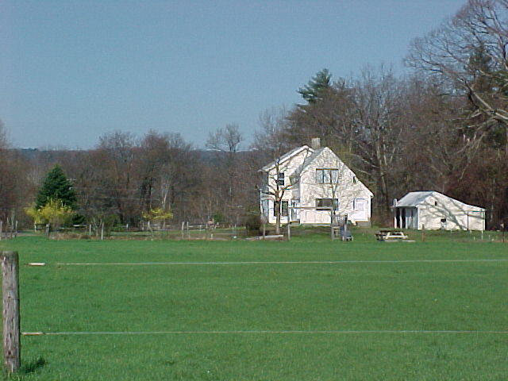

Offered by
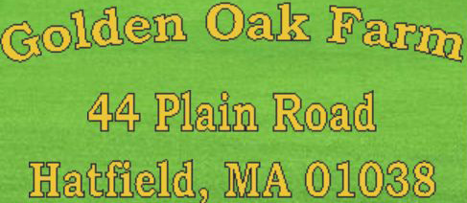

March 1, 2013

Introduction

Golden Oak Farm is offering a program for up to 4 students studying sustainable agriculture. Participating in the daily activities of a working farm allows students of organic agriculture to apply what they are taught in the classroom in a hands-on environment. Students will learn animal husbandry, intensive pasture management, and varied organic garden practices.

Executive Summary

Students will work on an organic farm, learning organic sustainable practices for vegetable growing, animal husbandry, and intensive pasture management that they can put into practice in future farming experiences. Students can acquire basic skills such as tool use, food preservation, butchering, and creating farm infrastructure if they choose. Academic credit or community service hours for the time spent on the farm are offered to fulfill academic requirements.
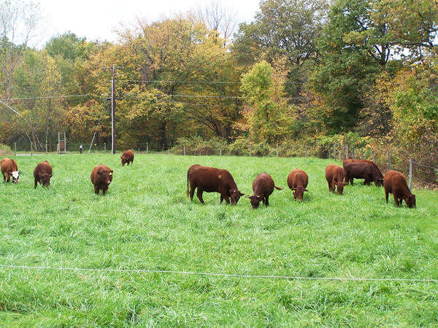

Project Description

Golden Oak Farm is an 8½ acre farm in Hatfield, MA where grass fed Devon beef cows, heritage pastured poultry, free range layers, and grass fed pigs are raised, along with organic vegetables. The farm has a small butcher shop where meat is processed for personal consumption.
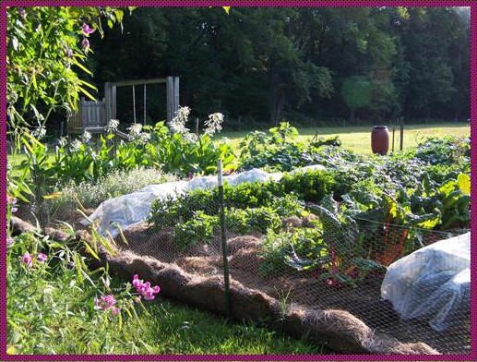

Gardening

Students are involved in daily work throughout the growing season, April – November, and learn:

- How to select seeds and start seedlings:
  - Timing
  - Conditions
  - Feeding
- When and how to plant a large variety of vegetables, herbs, and flowers
- Soil care:
  - Soil nutrient density
  - How to read a soil test
  - Determining soil amendment needs and how to apply them
- Plant and garden care
  - Foliar feeding and drenches
  - Using cover crops
  - Planting rotational crops
  - Harvesting practices

All processes are recorded to assist in determining what could have been done differently to improve the next year’s crops.

This information would be used to determine why pepper seedlings stopped thriving or why carrots did not do well with a cover crop as mulch.
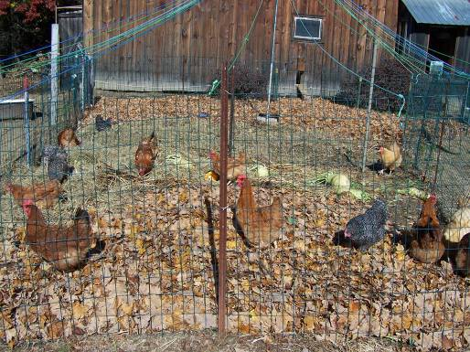

Animal husbandry

Proper and sustainable management of livestock is essential to a healthy farm. The cows’ grazing stimulates forage diversity and also spreads manure intensively on the pastures. The pigs make the compost that is then spread on the fields. Animal husbandry covers:

- Safe handling practices
- Feeding practices
- Nutrition
- Health
- Predator control
- Manure management systems
- Pest control
- Managing a laying flock
  - Behavior management
  - Culling

Poultry nutrition information would be used to determine why a pecking episode occurred.

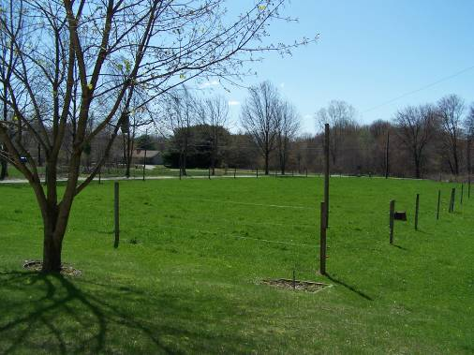

Pasture management

The goal is to increase the length of the grazing season into the fall and early winter, increase the productivity of the soil, increase the nutrient levels, and thereby decrease the amount of hay fed in late fall and early winter. Pasture management includes:

- Fencing knowledge
- Observation of forages and pasture quality
- Soil nutrition
- Managing animal grazing
- Pasture maintenance

Observation of forages teaches students how to read signs of improving pastures.

Extra Training Opportunities

Students can supplement their education by learning:

- Butchering practices for poultry, beef, and pork
- Food preservation techniques:
- Canning
- Freezing
- Dehydrating
- Pickling
- Root-cellaring
- Cooking techniques
- Use of hand tools and power tools
- Construction of farm infrastructure
- Repairs of equipment
- Wildlife observation

Course Materials

Students will receive written materials on the practices used on the farm:

- Gardening guides
- Poultry data
- Soil facts
- Butchering practices
- Nutritional information

These materials will also be made available on the internet.

Method

Golden Oak Farm offers to utilize a “time bank” system, exchanging hours of work in place of payment. In keeping with this philosophy of “time-banking”, the student will receive an education that they can turn into hours toward academic credit or Community Service, Golden Oak Farm will receive the benefit of work done during each day’s class.

Organization

Golden Oak Farm, founded in 1983, is an organic homestead farm in Hatfield, MA owned by Pam Raymond and David Turner.

Pam and David are disabled by invisible chronic illnesses due in part to lack of real nutrition in conventional food and unsafe additives. To improve their health and the health of their land, they began to explore sustainable food and farming practices. These practices have led to a marked improvement in their functional abilities and relief from many of the symptoms of chronic illness.
Through the ability to wonder at the magnificence of the natural world and how it functions holistically, they are learning to find a place in its rhythms. Respect for the life that feeds them, allowing it to live and die, in as natural a way as they can provide is essential to the operation of the farm. It’s a matter of respecting life and wanting the best food possible.

Pam and David work at educating others about growing their own food, finding better nutrition, and using better animal management practices through the many workshops they teach.

Conclusion

Students attending the Golden Oak Farm “Farm Practices Program” come away with a solid, working knowledge of sustainable farming practices and skills they will be able to employ in their future farming endeavors. Better pasture management of animals fosters improved soil nutrition and stronger forage growth. Better forage and animal husbandry practices allow the animals to experience better growth and health. In turn, better soil maintenance yields higher quantities of produce with higher nutritional value.

Having a greater understanding of how all farming practices work together on a farm will bring the student closer to understanding how nature works and encourage emulation of that model. This not only benefits the student, and the farm, but the earth also.

Contact Information

Pam Raymond dandp2002@yahoo.com
David Turner
http://goldenoakfarm.us/
44 Plain Road
Hatfield, MA 01038

413-247-9516

