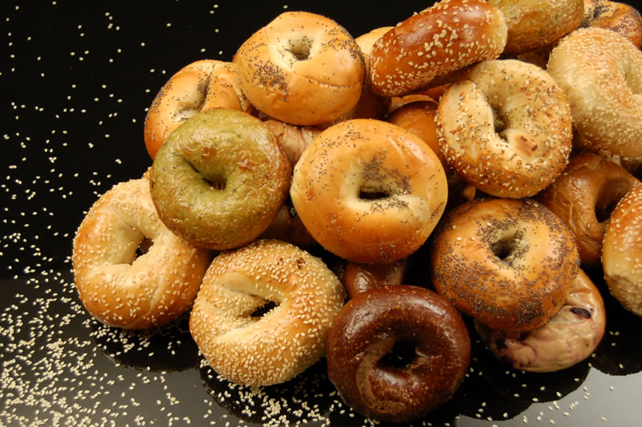

**BAGEL BONANZA!!**

Come join us this Sunday for a Pre-Passover Bagel Brunch!

Sponsored by the Jewish Student Union

## Sunday, September 21st

# Merrill Living Room

### 11:30am-12:30pm