
QIPOC
mini-Film
Festival

Organized by the Queer International and Students of Color student group at Hampshire College. Featuring two full-length, LGBTQ film festival favorites, by two African American Lesbian filmmakers.
(Plus two Hampshire student shorts!)
*HELD IN FRANKLIN PATTERSON HALL, MAIN LECTURE HALL*



Internationally acclaimed Underneath, feature film by Katrina Deaton This Friday MARCH 27, 2009 at 5pm
(Learn more at underneaththemovie.com)

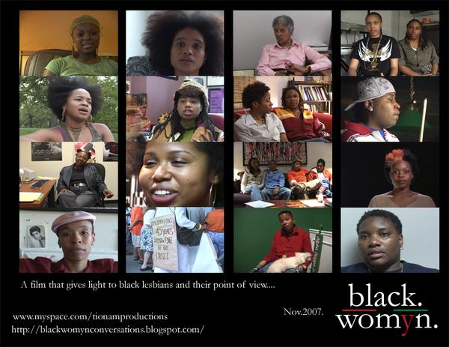
black./womyn.:
conversation
with lesbians of
african decent
a feature documentary
by award winning
filmmaker tiona m.
Saturday at 2pm
MARCH 28, 2009
*** Q&A WITH Director***
***TIONA M. AFTER***
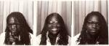
*** SCREENING***

