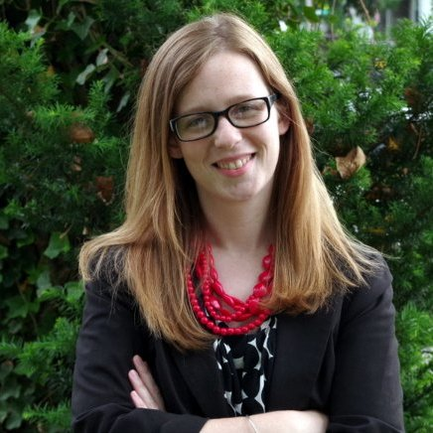

**Nonprofit Career Talk & Afternoon Tea**

**with Melissa Mills-Dick 01F**

Hampshire's new Director of Alumni and Family Relations got her start in non-profit communications, fundraising and operations here at Hampshire. Come hear about her journey from her RRASC internship to the National Network of Abortion Funds, to Planned Parenthood and back to Hampshire College, as well as her MFA in writing from Bennington College! Tea, treats, and excellent company.

**When**: Wednesday, October 15 3:30-4:30  
**Where**: CORC Office, 3rd Floor Harold Johnson Library