The Hampshire College Law Program Invites you to join us in considering our collective future:

“National Security within a Human Rights Framework”

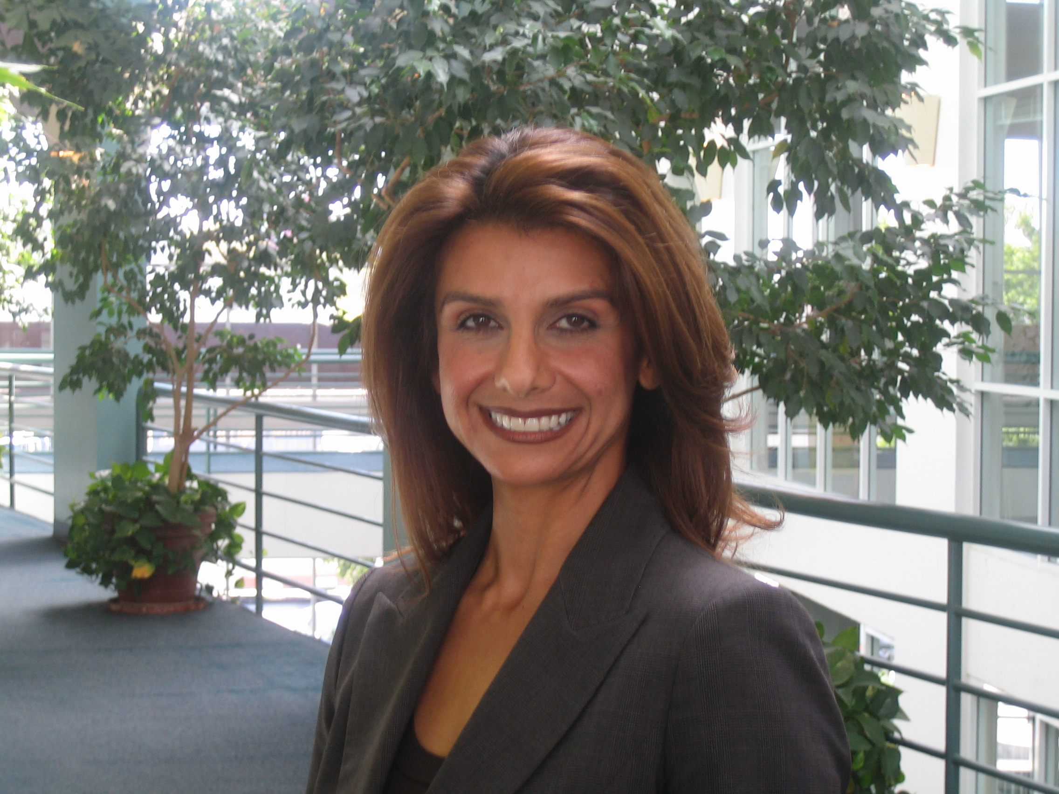
Banafsheh Akhlaghi, Esq.

National Legal Sanctuary for Community Advancement

Ms. Akhlaghi will explore how national security objectives can be achieved through a human rights framework, and how human security as the genesis of the dialogue can lead to effective national and international security policies. In her talk, she will look at successful models in Northern Ireland, truth and reconciliation commission of South Africa and the redress movement in the United States can aid in providing a new perspective in our approach today.

Tuesday, April 8, 2008 at 5 pm

West Lecture Hall
Franklin Patterson Hall
Hampshire Campus

Until 2001, Ms. Akhlaghi, an attorney of Iranian descent, was a professor of Constitutional Law at the John F. Kennedy University School of Law, in California. After September 11, 2001, Ms. Akhlaghi gave up her teaching position to represent nearly 2,700 individuals of Muslim, Middle Eastern, and South Asian descent, who have been detained or questioned by the FBI and the Dep’t. of Homeland Security. In the process, she founded the National Legal Sanctuary for Community Advancement.

In May of 2005, NLSCA began to focus on human rights at the international level, when Ms. Akhlaghi was retained as a consultant to the United Nations Development Fund for Women (UNIFEM). She has testified before Congress on numerous occasions, including the 2003 Amnesty International Racial Profiling Hearings, and she regularly conducts cultural Sensitivity Trainings with branches of the Equal Employment Opportunity Commission (EEOC). She has won numerous awards from the media, legal associations, and the U.S. Congress.

Ms. Akhlaghi has been featured on Democracy Now, and her clients have been profiled in the Wall Street Journal, New York Times, CNN, and other major media.

Sponsored by the Hampshire College Law Program and the Program in Global Migrations in the School of Social Science

