HAITI Action Meeting

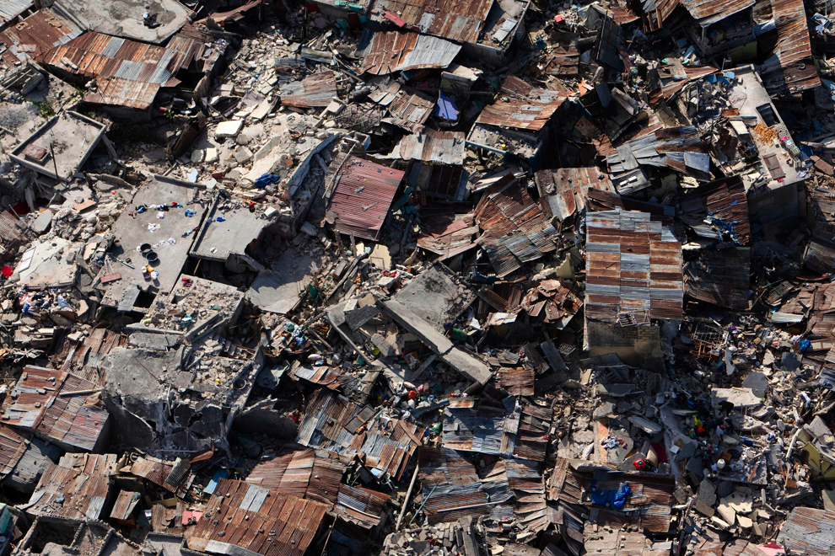

Thursday Feb. 4th at 12PM
In the Airport Lounge

A coalition of students, faculty, and staff is forming to organize relief efforts on campus, and to educate ourselves and the community about the colonial and post-colonial history of Haiti.
Come and get involved!

