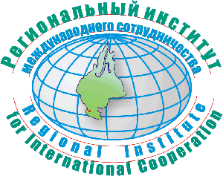
Tyumen State University
Regional Institute for International Cooperation

Russian Language & Culture Summer School
Tyumen, 03 -24 July, 2010

Enter Russia through Siberian Gates! Tyumen is the first Siberian city (1586), multinational and dynamic, a city with old traditions and young people.

Join our unique project for students and staff, interested in studying the Russian language and learning about the country. The course is designed to allow acquisition or fast improvement of the language skills, while being immersed into the authentic Russian culture. The participants will have an opportunity to be involved in a variety of interactive educational projects to experience the Russian cultural diversity and to get an idea of the economy, geography and history of Western Siberia.

80 academic hours of class-room learning

50 academic hours of project work (Language and Country Studies)

5 ECTS points awarded for completion of the course

Classroom learning:
- Russian Language courses for foreigners (60 hours)
- Courses on the Russian and Siberian History, Economics, Geography and Culture (20 hours)

Language and Country Studies:
- Acquaintance with the city of Tyumen and its inhabitants
- Visits to the local museums and churches
- Bus excursions to the countryside, visiting places of local

cultural heritage
- Excursion to the town of Tobolsk (the ‘pearl’ of Siberia), a visit to

the unique Kremlin, historical Old Town and local museums
- Cinema club (film-watching in the Russian language + discussion)
- Discussion of the new cultural and language experience
- Preparation of group projects and presentations

Accommodation:

The participants are provided with double rooms in a student hostel.

Accommodation in a single room in a student hostel can be provided on participant’s request (at additional cost). The Internet access is available.
- The classes take place in the morning, between 9.30 and 12.45
- Excursions and project work are planned for the afternoons and weekends.

Cost of the program (incl. tuition fee, cultural program and excursions,

accommodation): 780 euro

The deadline for applications: the 1st of April, 2010.

If you have any questions, please, do not hesitate to contact us:

Regional Institute for International Cooperation
at Tyumen State University
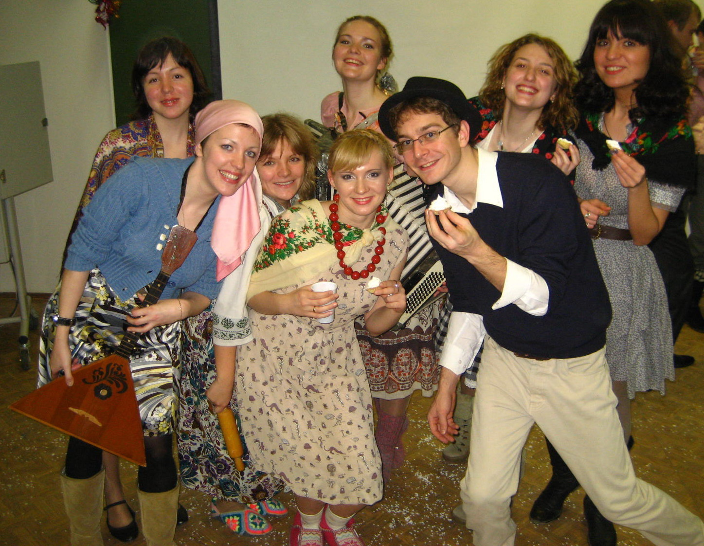
10, Semakova Str.,
625003, Tyumen, RF

Tel.: 007 (3452) – 455704 / 455703
Fax: 007 (3452) – 455703 / 455086
E-mail: riic@utmn.ru; dvtelegin@mail.ru;
ezhukova@utmn.ru
http://riic.utmn.ru

