“Gripping… Durham demonstrates that he is a master of the fantasy epic.”
– The Washington Post

Join author David Anthony Durham for a reading from his internationally acclaimed fantasy series!

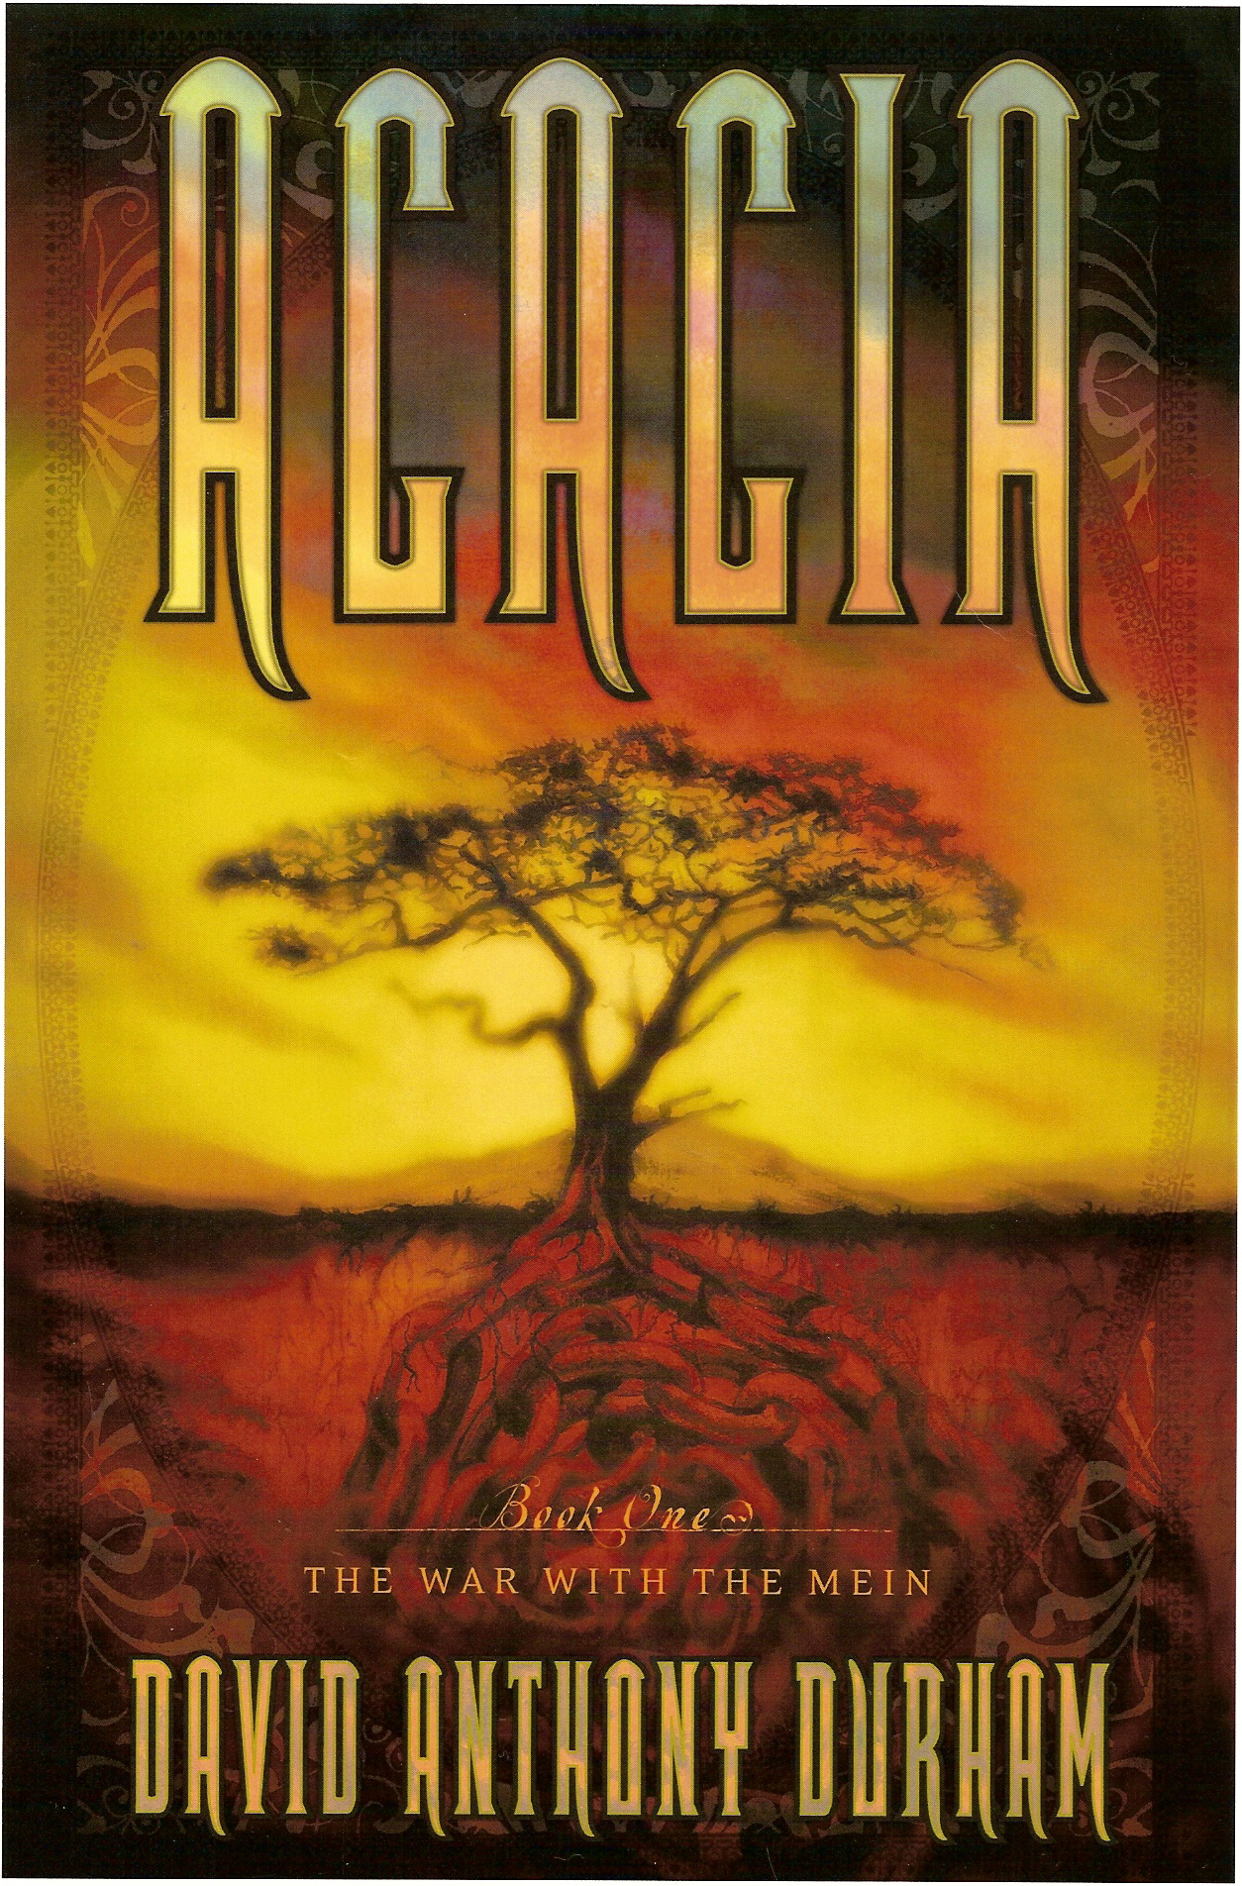

About the Author: In addition to the Acacia novels, David is the author of Pride of Carthage, Walk Through Darkness and Gabriel’s Story. His work has been translated into eight languages.

The Oddysey Bookshop, South Hadley, Dec 3rd, at 7pm.



