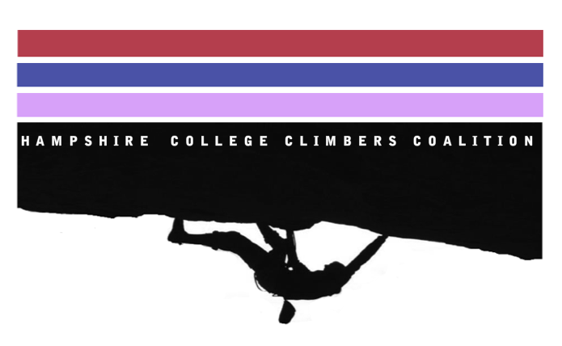
Hampshire College Climber’s Coalition
Central Rock Gym Membership Contract

**Please send in this contract from your Hampshire email**

By signing this agreement form, I, __________________________, agree to the following terms and conditions:
1. I am currently enrolled at Hampshire College and participate in the Hampshire College Climbers Coalition.
Initials: ___________________________________________________________________________________
2. If I do not scan in and climb four times during the month of April 2013 at Central Rock Gym with the Hampshire sponsored membership slot card, I agree to pay the Hampshire College Student Account Funds (SAF) for the membership slot in the amount of $35.00.
Initials: ___________________________________________________________________________________
I hereby understand and agree to all of the above.
Signature: ________________________________________________________________________________
Date: ____________________________________________________________________________________

